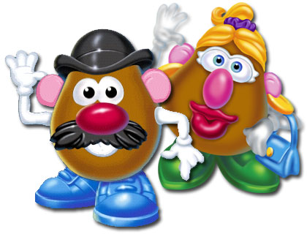
ALL ABOUT ME POTATO HEAD PROJECT

The Original Mr. Potato Head of the 1950s was a handful of pushpin pieces resembling noses, ears, mouths, and eyes and were found in a cereal box. Kids then used the pieces to make faces on their own veggies. But now almost 60 years later, this one simple idea is a multimillion-dollar toy. This is proof that a simple idea can and will spark success!

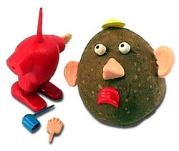
You are a Lesterland Toy Designer. You have been assigned the very important All About Me POTATO HEAD PROJECT. It is up to you to recreate the fabulous “retro” look of an original Potato Head with only a potato and parts YOU CREATE. This Potato Head is special because he or she will represent YOU. Use your imagination as George Lerner did in 1950 and create a completely new toy. Every aspect of your spud’s face, wardrobe and accessories should represent something special about you. Your spud may even come in a presentation box decked out to look like an important room or environment. On the day of your presentation, Monday August 11, you will bring in your original Mr. Potato Head to the Lesterland Toy Company’s board meeting. You will present your Spud before the board of your peers and explain how your special design represents the many things that make you special.
Photos of all will be posted throughout Lesterland.

All About Me Potato Head Project RUBRIC
DUE Monday, August 11, 2025 (How will you be graded?)
points | Specifics
10 | A completely original Mr. Potato Head must be ready to be presented on the due date, Monday August 11
25 | Creativity matters!!! The final Spud must show that real thought and planning was put into the project. Use the potato to share goals and dreams with the audience. Designers may choose to dress the potato to look like a favorite sport, career goal or fun family hobby. Dressing Mr. Potato Head in special clothing and having him hold objects that remind the designer of the place they visited could represent a special vacation memory. The more interesting the decorations, the more interested your audience will be in your presentation.
40 | Each toy creator must make an oral presentation to the class explaining how their spud represents something special about themselves personally. The presentation or speech must be well prepared. All speeches should be written out completely in final draft form - pen or typed 12-point Times New Roman. Note cards may be used to explain the details of each potato head part during the speech but they do not count as a written draft. The presentation must be interesting. Tell a story about why the potato looks the way he does. Be sure to practice the speech.  This is your first presentation – your first impression. WOW US!!
10 | The audience must learn something new about hobbies, interests, family, or future goals of the spud designer.
10 | Handmade parts are a requirement. Please do not go out and buy a Hasbro Mr. Potato Head. Designers must use an actual potato or sweet potato, or similar veggie found at the grocery store. The entire project must be original.
5 | Presentation must be at least 1 to 2 minutes in length. A timer will be used. HAVE FUN WITH THIS!

Please text questions to Dr. Lester on CLASS DOJO or email Lester.kimberly@muscoge.k12.ga.us

